Scan Here to Check-In!

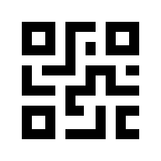
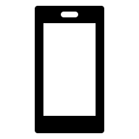
Use your smartphone and open the Chorus Connection app to display your QR Code.



Apple App Store | Google Play Store
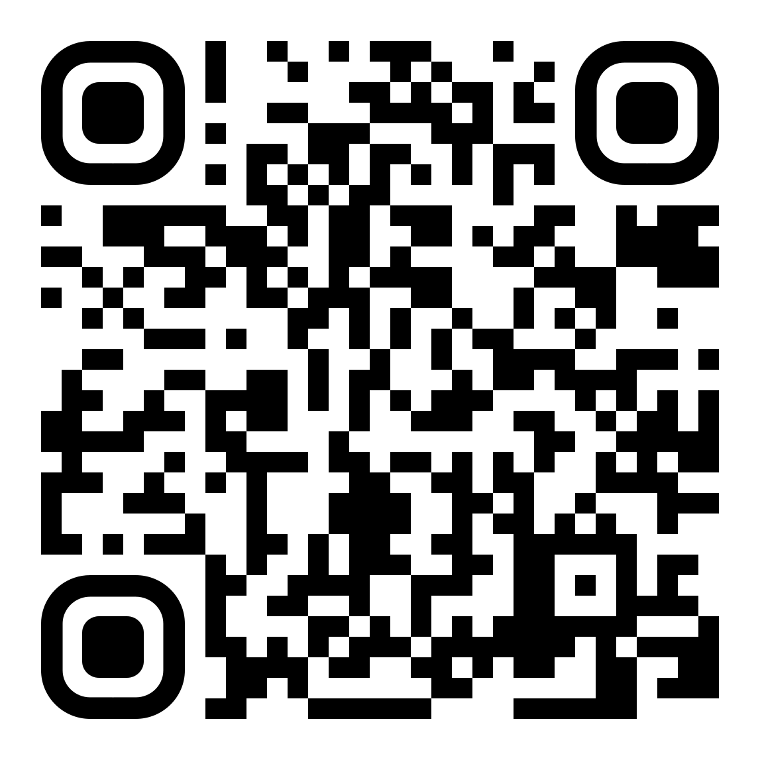 | 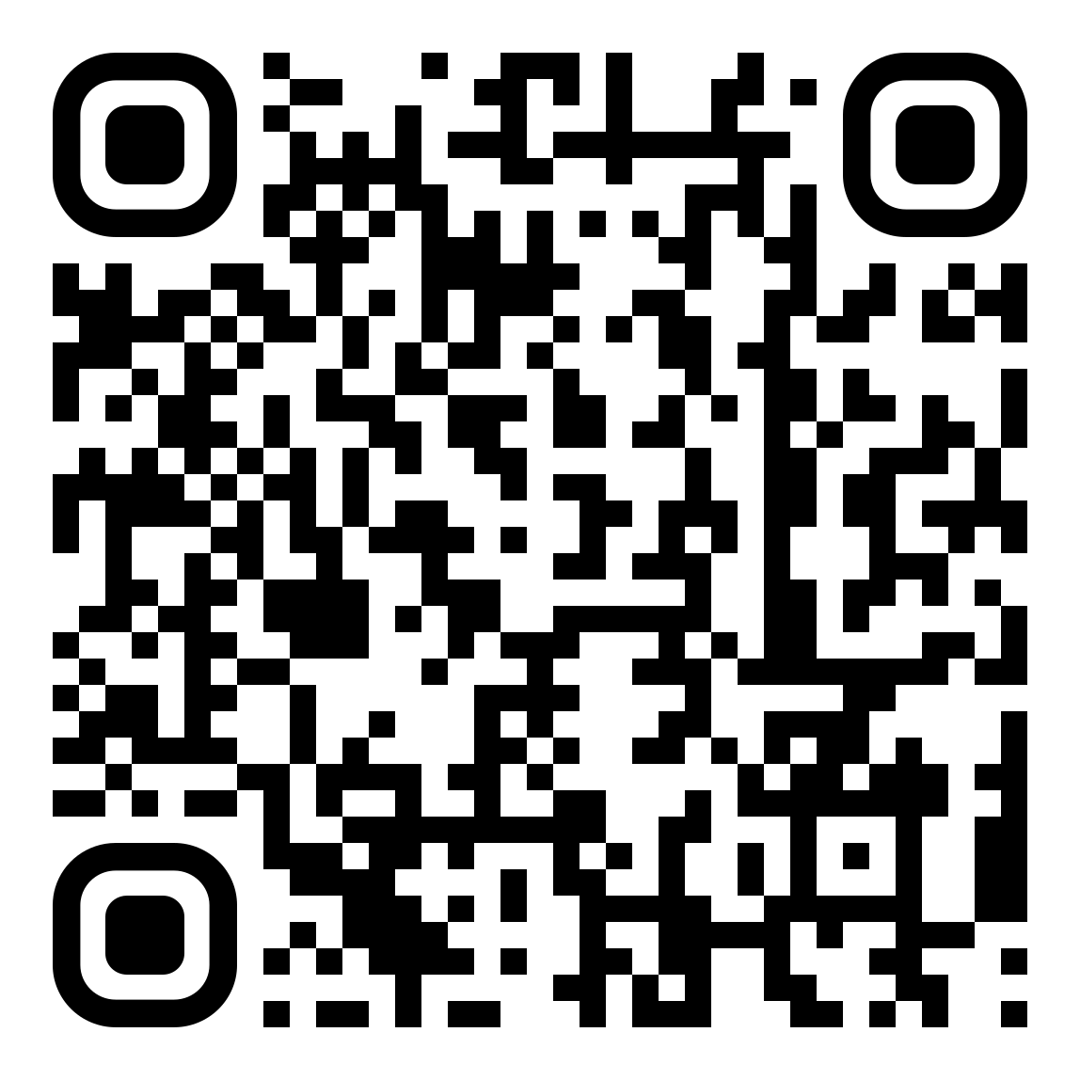

Get the Chorus Connection App!

